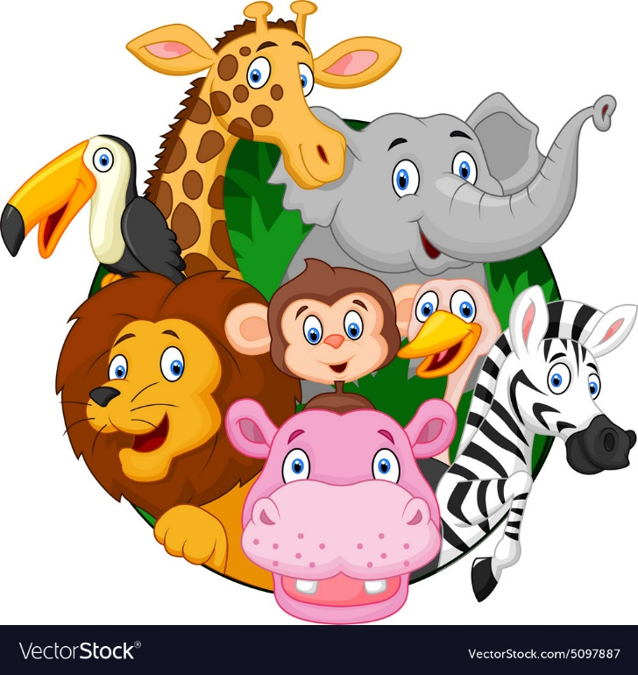

My communication:

Key texts:

Dear Zoo

A perfect day

Mine!

Zoo

Elma

Big Little Hippo

Aesops Fables

A squash and a squeeze

Rumble in the Jungle

Noah’s Ark

WOW experiences:

Animal Experience

Zoo

PAT dog

Ducklings

My thinking;

Problem solving:

Ordering Animal Care

Categorising animals ‘

Environmental Issues

Matching babies to animals

Sequence Life Cycles

Match animal to habitat

Maths:

Catergorising animals – Size, Legs, Colour

Numbering and counting animals

Graphs data and surveys about animals

My play

Role play as animals

Dressing up play – masks etc

Animal small world

Zoo role play areas

Face painting

Playing with actual animals

Tamogocci

Feeling animal boxes

Home learning opportunities:

Trips out to the park, the zoo or the river

Experiences with family pets

Garden centres – Scotsdales, 20 Pence etc.

My world:

Life Cycles

Learning about Habitats

Georgraphy – where animals live

Scavenger hunts

Nest building

Listen to sounds of the animals as they explore how they feel.

Look in mirrors to explore how they look.

My body and well being

Animal Yoga

Animal Dance

Comparing animal bodies to human ones

Horse care

Care for other animals

Sensory Massage story

Interventions:

PAT Dog

Lego Therapy

Colourful Semantics

Touch and taste

Rebound

My independence

How to look after a pet

PAT dog care

Interactive animal care games

Looking after ducklings and butterflies

My communication: literacy activities

Animal Songs

Sensory stories

Reading to Marley

Describing Animals

Mixed up animal – fictional names

Animal exploration – I feel PECS

Dairy of an animal

Animal Noise – I hear PECS

Animal Nouns

Animal Phonics

Colourful Semantics

**Animal Kingdom**